Knight Swap Puzzle
Solving a Classic Chess Puzzle Using Breadth-First Search

1. Problem Description

1.1 What is the Knight Swap Puzzle?
The Knight Swap Puzzle is a well-known combinatorial puzzle played on a 4 × 3 chessboard. Six knights are placed on the board — three white and three black. The challenge is to swap the positions of the two groups using only legal chess knight moves.

1.2 Initial and Goal States
The board begins and must end in the following configurations:

 | Col 0 | Col 1 | Col 2
Row 0 (Start) | Black (B) | Black (B) | Black (B)
Row 1 (Start) | Empty | Empty | Empty
Row 2 (Start) | Empty | Empty | Empty
Row 3 (Start) | White (W) | White (W) | White (W)

 | Col 0 | Col 1 | Col 2
Row 0 (Goal) | White (W) | White (W) | White (W)
Row 1 (Goal) | Empty | Empty | Empty
Row 2 (Goal) | Empty | Empty | Empty
Row 3 (Goal) | Black (B) | Black (B) | Black (B)

1.3 Movement Rules
Each knight moves exactly as in standard chess: an L-shaped hop of two squares in one direction followed by one square perpendicular. From any cell, up to eight destinations are possible. In this puzzle:
- Knights may not capture each other — a knight can only move to an empty cell.
- The goal is to reach the swapped configuration in the minimum number of moves.

1.4 Why is this Challenging?
A 4×3 board has 12 cells. With 6 knights placed, the remaining 6 are empty. The number of possible board configurations is the number of ways to distribute 3 white knights, 3 black knights, and 6 empty cells across 12 positions — a large space to search through manually. The optimal solution requires exactly 16 moves, which is non-trivial to find without a systematic algorithm.
2. Underlying Assumptions
The following assumptions were made before designing the solution:

- Fixed board dimensions: The board is always 4 rows by 3 columns. The algorithm is not designed to generalise to arbitrary sizes without code modification.

- Standard knight movement: All eight L-shaped moves are valid. A move is only rejected if the destination falls outside the board boundary or is occupied.

- No captures: Knights of either colour cannot move to a cell already occupied. They may only land on empty cells.

- Either color can move each turn: There is no alternating-turn constraint. Any knight (white or black) may be moved at any step.

- A solution always exists: The starting and goal configurations are fixed and reachable from each other. The BFS will always find a path.

- Optimal solution required: BFS guarantees the shortest path. The implementation does not stop early or use heuristics that might sacrifice optimality.

- Memory is not a constraint: The entire state space is stored in memory using hash maps. For this board size this is feasible on any modern computer.

- Single-threaded execution: The algorithm runs on a single CPU thread. No parallelism is assumed or required.

Note on board encoding: Each cell holds one of three values (0 = empty, 1 = white, 2 = black). The board is encoded as a 12-digit base-3 integer, giving each unique configuration a distinct numeric fingerprint used as a hash map key.

3. Solution Methodology

3.1 Algorithm Choice: BFS
The problem is modelled as a state-space search. Each unique arrangement of knights on the board is a state, and each legal knight move is a transition between states. The goal is to find the shortest sequence of transitions from the start state to the goal state.
Breadth-First Search (BFS) is the natural choice for this type of problem. It explores all states reachable in k moves before exploring any state reachable in k+1 moves, so the first time it reaches the goal state it is guaranteed to have taken the shortest possible route.

3.2 State Representation
A board state is stored as a BoardState struct containing a 4×3 integer array. Each cell holds 0, 1, or 2. The struct also provides an encode() method that converts the array into a single long long using base-3 arithmetic, producing a unique fingerprint for fast hashing.

3.3 Step-by-Step Methodology
The solution proceeds in the following stages:

Step | Action | Detail
1 | Build boards | Construct the fixed start and goal BoardState objects
2 | Initialise BFS | Push start onto queue; mark it visited with parent = -1
3 | Expand frontier | Pop front board; generate all legal one-move successors
4 | Check goal | If current board == goal, stop and reconstruct path
5 | Mark visited | For each successor not in parentOf map, record parent and enqueue
6 | Reconstruct path | Walk parentOf backwards from goal to start, then reverse
7 | Print solution | Output each board in the path with its move number

3.4 Data Structures Used
Structure | Type | Purpose
statesToExplore | std::queue | FIFO frontier for BFS level-order traversal
parentOf | std::unordered_map | Visited set + parent pointer; key = encoded board
boardOf | std::unordered_map | Maps encoded ID back to full BoardState for reconstruction
solutionPath | std::vector | Final list of boards from start to goal
4. Pseudocode

FUNCTION solveWithBFS(startBoard, goalBoard):
goalCode <- encode(goalBoard)
startCode <- encode(startBoard)

parentOf[startCode] <- -1 // -1 means 'no parent'
boardOf[startCode] <- startBoard
queue.push(startBoard)

WHILE queue is not empty:
current <- queue.pop_front()
currentCode <- encode(current)

IF currentCode == goalCode THEN
// Reconstruct path
path <- []
code <- goalCode
WHILE code != -1:
path.prepend(boardOf[code])
code <- parentOf[code]
RETURN path

FOR EACH nextBoard IN findAllNextMoves(current):
nextCode <- encode(nextBoard)
IF nextCode NOT IN parentOf THEN
parentOf[nextCode] <- currentCode
boardOf[nextCode] <- nextBoard
queue.push(nextBoard)

RETURN [] // No solution found

────────────────────────────────────────────────────────

FUNCTION findAllNextMoves(board):
moves <- []
FOR EACH cell (row, col) in board:
IF cell is not EMPTY:
knight <- board[row][col]
FOR EACH (dr, dc) in KNIGHT_OFFSETS:
destRow <- row + dr
destCol <- col + dc
IF destRow and destCol are within bounds
AND board[destRow][destCol] is EMPTY:
newBoard <- copy of board
newBoard[row][col] <- EMPTY
newBoard[destRow][destCol] <- knight
moves.append(newBoard)
RETURN moves

5. Implementation Code
The complete C++ source is presented below, broken into logical sections with explanations.

5.1 Constants and Board Definitions
static const int NUMBER_OF_ROWS = 4;
static const int NUMBER_OF_COLS = 3;
static const int EMPTY_CELL = 0;
static const int WHITE_KNIGHT = 1;
static const int BLACK_KNIGHT = 2;

// 8 possible knight move offsets (row, col)
static const int ROW_CHANGE[8] = { -2,-2,-1,-1,+1,+1,+2,+2 };
static const int COL_CHANGE[8] = { -1,+1,-2,+2,-2,+2,-1,+1 };

5.2 BoardState Struct
struct BoardState {
int cell[NUMBER_OF_ROWS][NUMBER_OF_COLS];

// Encode board as a unique base-3 integer
long long encode() const {
long long n = 0;
for (int r = 0; r < NUMBER_OF_ROWS; r++)
for (int c = 0; c < NUMBER_OF_COLS; c++)
n = n * 3 + cell[r][c];
return n;
}

bool operator==(const BoardState& o) const {
for (int r = 0; r < NUMBER_OF_ROWS; r++)
for (int c = 0; c < NUMBER_OF_COLS; c++)
if (cell[r][c] != o.cell[r][c]) return false;
return true;
}
};

5.3 findAllNextMoves()
std::vector<BoardState> findAllNextMoves(const BoardState& board) {
std::vector<BoardState> next;
for (int r = 0; r < NUMBER_OF_ROWS; r++) {
for (int c = 0; c < NUMBER_OF_COLS; c++) {
if (board.cell[r][c] == EMPTY_CELL) continue;
int knight = board.cell[r][c];
for (int m = 0; m < 8; m++) {
int dr = r + ROW_CHANGE[m];
int dc = c + COL_CHANGE[m];
if (dr < 0 || dr >= NUMBER_OF_ROWS) continue;
if (dc < 0 || dc >= NUMBER_OF_COLS) continue;
if (board.cell[dr][dc] != EMPTY_CELL) continue;
BoardState nb = board;
nb.cell[r][c] = EMPTY_CELL;
nb.cell[dr][dc] = knight;
next.push_back(nb);
}
}
}
return next;
}

5.4 solveWithBFS()
std::vector<BoardState> solveWithBFS(
const BoardState& start, const BoardState& goal) {
long long goalCode = goal.encode();
long long startCode = start.encode();
std::unordered_map<long long, long long> parentOf;
std::unordered_map<long long, BoardState> boardOf;
parentOf[startCode] = -1;
boardOf[startCode] = start;
std::queue<BoardState> q;
q.push(start);
while (!q.empty()) {
BoardState cur = q.front(); q.pop();
long long curCode = cur.encode();
if (curCode == goalCode) {
std::vector<BoardState> path;
long long code = goalCode;
while (code != -1) {
path.push_back(boardOf[code]);
code = parentOf[code];
}
std::reverse(path.begin(), path.end());
return path;
}
for (auto& nb : findAllNextMoves(cur)) {
long long nc = nb.encode();
if (!parentOf.count(nc)) {
parentOf[nc] = curCode;
boardOf[nc] = nb;
q.push(nb);
}
}
}
return {};
}

6. Time and Space Complexity Analysis

6.1 State Space Size
The board has 12 cells. We place 3 white knights, 3 black knights, and 6 empty cells. The maximum number of distinct board configurations is bounded by 3^12 = 531,441. In practice far fewer states are reachable from the start position, but BFS may still explore thousands of them.

6.2 Time Complexity
Operation | Cost | Explanation
encode() | O(1) | Fixed 12-cell grid, always 12 iterations
findAllNextMoves() | O(1) | At most 12 cells × 8 moves = 96 checks, all bounded
Hash map lookup | O(1) avg | unordered_map with long long key
BFS overall | O(S) | S = number of reachable states (explored at most once each)
Path reconstruction | O(L) | L = solution length (16 steps in this case)

6.3 Space Complexity
Structure | Space | Note
boardOf map | O(S × 48 bytes) | Each BoardState is 12 ints = 48 bytes on most platforms
parentOf map | O(S × 16 bytes) | Two long long values per entry
BFS queue | O(S) | At most all states queued simultaneously
Solution path | O(L) | 16 boards in the final path

Bottom line: For this specific board size, both time and space are effectively O(1) from a practical standpoint — the state space is small enough that the program runs in milliseconds and uses well under 1 MB of memory.

7. Comparative Evaluation of Techniques
Technique | Optimal? | Complete? | Memory Use | Speed | Verdict
BFS (used) | Yes | Yes | High | Moderate | Best for guaranteed optimality
DFS | No | Yes | Low | Fast | May find very long non-optimal paths
Iterative Deepening DFS | Yes | Yes | Low | Moderate | Good compromise; slower than BFS in practice here
A* Search | Yes* | Yes | Medium | Fast | Optimal with admissible heuristic; harder to implement
Bidirectional BFS | Yes | Yes | Medium | Faster | Explores from both ends; ~half the states
Random/Greedy | No | No | Low | Variable | No guarantee of finding solution

BFS was selected because it is simple to implement correctly, guaranteed to find the shortest path, and the state space is small enough that memory usage is not a concern. For larger boards, bidirectional BFS or A* would become preferable.

8. Sample Outputs
The program prints every board state from start to goal. Below are the first three moves, the midpoint, and the final state.
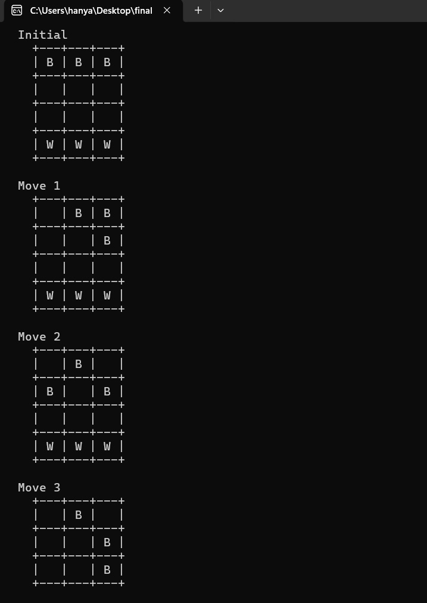
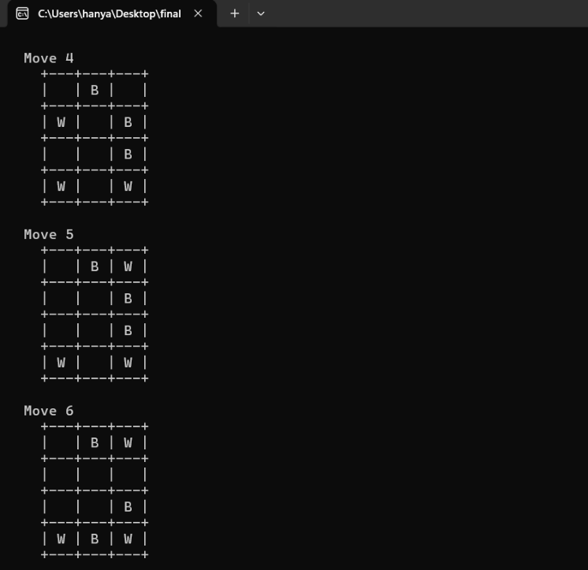
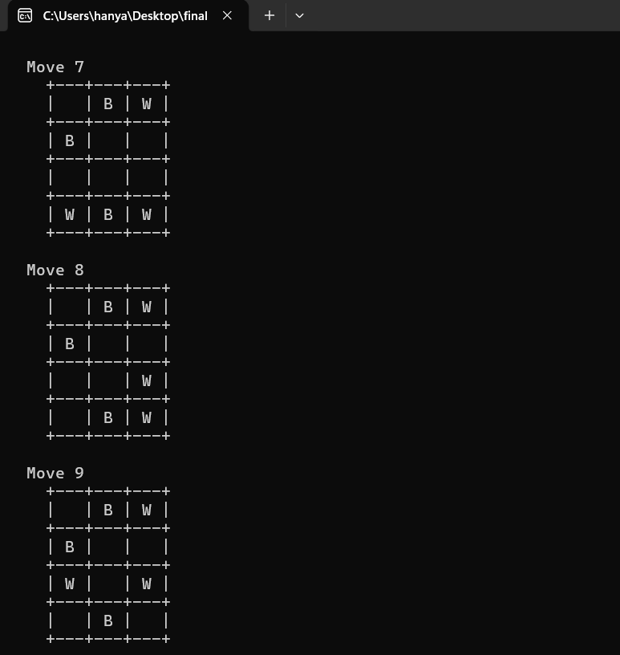
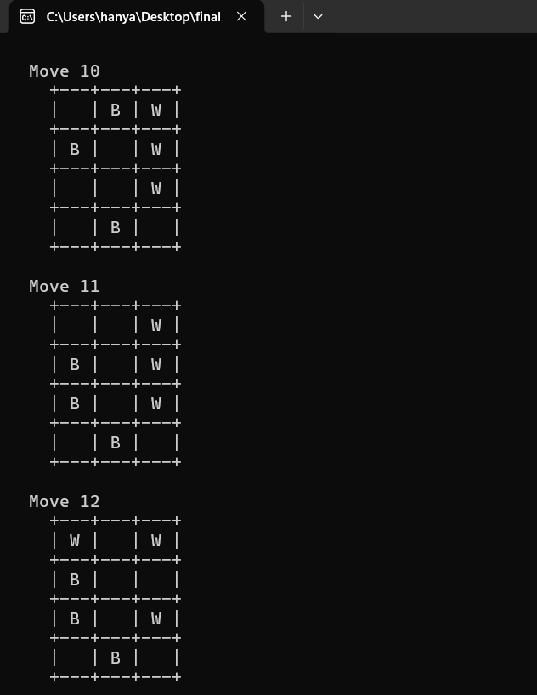
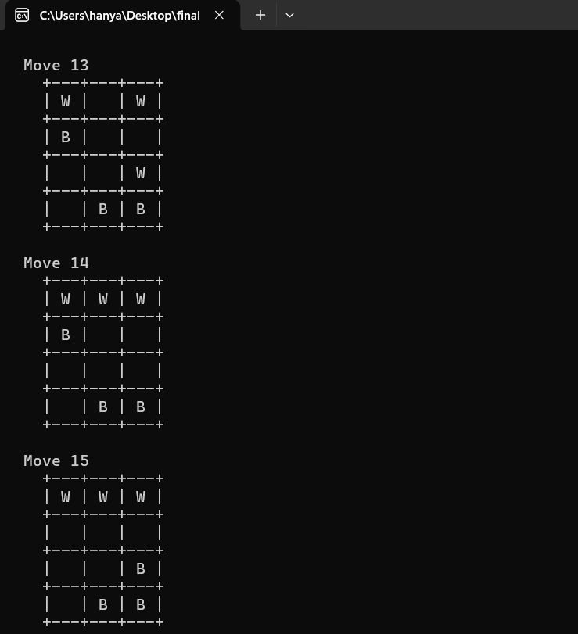
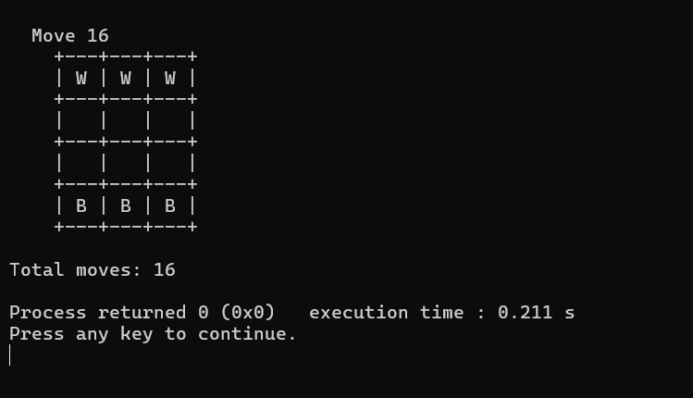

9. Key Findings and Insights

9.1 Findings
- BFS is optimal for this problem: It reliably finds the 16-move solution every time, with no possibility of returning a longer path.

- State encoding is critical: Converting a board to a single integer with base-3 encoding makes hash-map operations O(1), which is essential for BFS performance.

- The state space is manageable: Despite the theoretical upper bound of 531,441 states, BFS solves the puzzle almost instantly, indicating the reachable state space is much smaller.

- No heuristic is needed at this scale: BFS works well here because the puzzle is small. For larger knight-swap puzzles (e.g. 6×4), a heuristic would become necessary.

- Code clarity aids correctness: Naming constants (WHITE_KNIGHT, EMPTY_CELL) and separating concerns into small functions (findAllNextMoves, solveWithBFS) made the logic easy to verify and debug.

